**Product Backlog**

**Milestones**

**Sprint Forecast**

Team Oriented Project

Team D  
Data Acquisition and Development Tool

Date:

**October 2024**

**Cooperation with Institute for Mechatronics and Medical Engineering**

**Technische Hochschule Ulm**Piro, Neltje EmmaMoosbauer, Sebastian

Graf, Philipp

**What have we achieved so far?**  
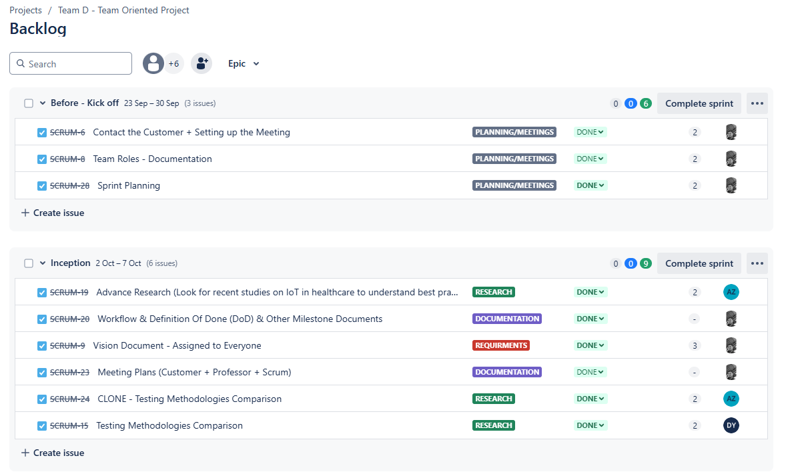

### **Summary (Before Kickoff and Inception Phases)**

#### **Before - Kickoff (23 Sep - 30 Sep)**

1. **SCRUM-6:** Contacted the customer and set up the meeting – Completed.
2. **SCRUM-8:** Defined team roles and documented them – Completed.
3. **SCRUM-28:** Sprint planning for the upcoming tasks – Completed.

#### **Inception (2 Oct - 7 Oct)**

1. **SCRUM-19:** Conducted advanced research on IoT in healthcare – Completed.
2. **SCRUM-20:** Defined the workflow and milestones like the Definition of Done (DoD) – Completed.
3. **SCRUM-9:** Drafted the vision document and assigned it to everyone – Completed.
4. **SCRUM-23:** Set up meeting plans with the customer, professor, and Scrum team – Completed.
5. **SCRUM-24:** Compared testing methodologies (CLONE) – In progress.
6. **SCRUM-15:** Compared testing methodologies – Completed.

**Sprint Forecast -   
Note:** Development is planned to start after the meeting with our customer this week  
  
  
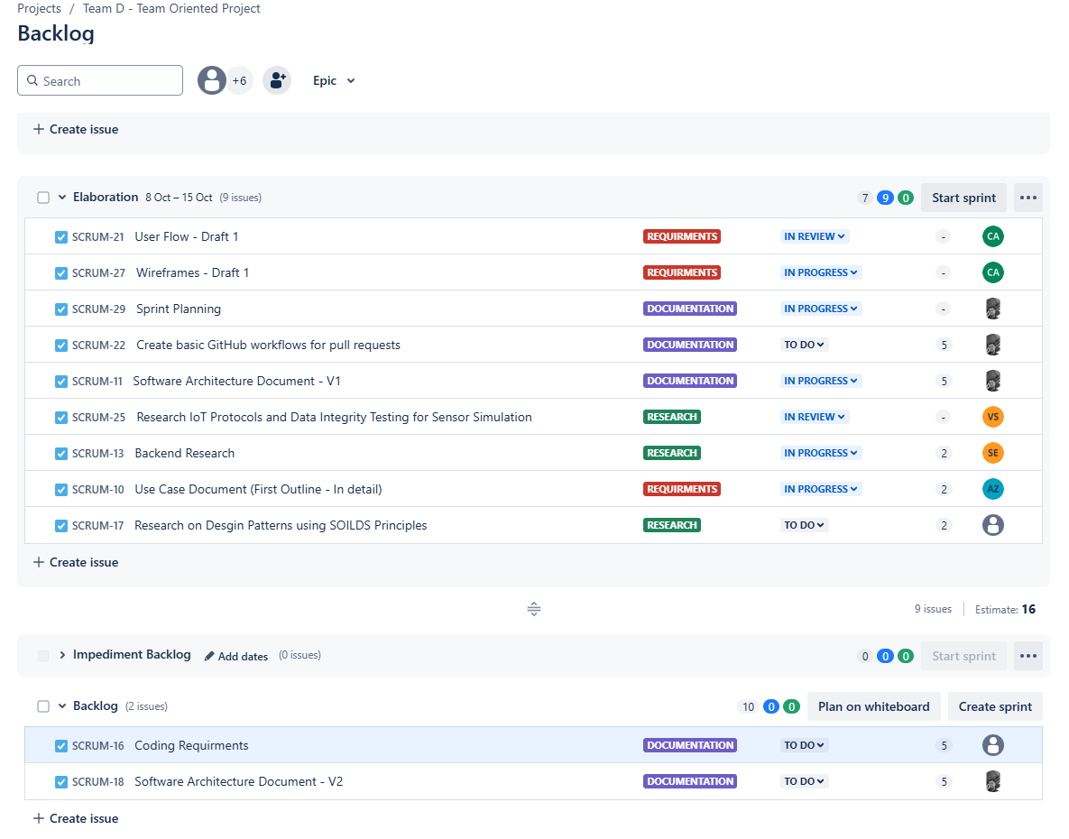

### **Summary of (Elaboration Phase)**

#### **Elaboration (8 Oct - 15 Oct)**

1. **SCRUM-21:** Drafted the user flow (First Draft) – In progress.
2. **SCRUM-27:** Created wireframes (First Draft) – In progress.
3. **SCRUM-29:** Sprint planning for the next tasks – In progress.
4. **SCRUM-22:** Planned to create GitHub workflows for pull requests – To do.
5. **SCRUM-11:** Started drafting Software Architecture Document (Version 1) – In progress.
6. **SCRUM-25:** Research on IoT protocols and data integrity testing – In progress.
7. **SCRUM-13:** Continued backend research – In progress.
8. **SCRUM-10:** Began outlining the use case document (First detailed draft) – In progress.
9. **SCRUM-17:** Planned to research design patterns using SOLID principles – To do.

**Milestones**

The team is dedicated to provide high quality documents with intensive development throughout the project timeline. A high level overview is elaborated below

1. **Mid-October 2024 (Development Kickoff)**
   * **Start of Development**: Officially start the development phase after the customer meeting.
   * **Data Acquisition Module (Phase 1)**: Implement the basic functionality to connect the tool with sensors (PPG and IMU) and retrieve raw data.
   * **Algorithm Integration Setup**: Begin integrating basic data processing algorithms (motion artifact removal, basic filtering).
   * **Software Architecture Finalization**: Lock in architecture decisions and ensure the project is compatible with Python for future algorithm development.
   * **Testing Methodologies in Place**: Establish the testing environment for real-time sensor data processing and basic data validation.
2. **End of October 2024 (Development in Full Swing)**
   * **Functional Prototype (Version 1)**: Complete the first version of the tool, capable of basic sensor data acquisition and real-time display.
   * **User Testing (Round 1)**: Start testing the tool with live data, focusing on stability and data accuracy.
   * **Backend Integration (Phase 1)**: Finalize the connection between the backend and the sensor data, including storing data locally with basic encryption.
   * **Wireframes and User Interface (Version 1)**: Implement a basic user interface for configuring sensors and monitoring data in real-time.
   * **Sprint Review & Retrospective**: Conduct a review with stakeholders on the first functional prototype and gather feedback for improvements.
3. **Mid-November 2024 (Final Development Push)**
   * **Advanced Data Processing**: Complete the integration of advanced data processing algorithms (motion artifact correction, data anonymization).
   * **User Interface (Final Version)**: Finalize the UI with all required features, including data filtering, display customization, and debugging tools.
   * **Backend Integration (Final Version)**: Implement the complete backend, including encrypted data storage and the ability to handle multiple platforms concurrently.
   * **Final Functional Prototype**: Deliver the final prototype capable of live monitoring, data storage, and basic data privacy measures (encryption and anonymization).
   * **User Testing (Round 2)**: Conduct more extensive user testing, simulating multiple platforms and high data throughput scenarios.
   * **Sprint Review & Retrospective**: Review the final prototype with stakeholders and make final adjustments based on feedback.
4. **End of November 2024 (Project Closure)**
   * **Final Prototype Delivery**: Deliver the fully functional and stable version of the tool with all major features implemented.
   * **Final User Testing**: Complete final testing and bug fixes based on feedback from the customer and stakeholders.
   * **Documentation Completion**: Finalize technical documentation (system architecture, design patterns, test plans), user manuals, and maintenance guidelines.
   * **Final Presentation**: Prepare and deliver a final presentation to stakeholders, demonstrating the tool's functionality and providing an overview of the development process.
   * **Project Wrap-Up**: Conduct a final sprint retrospective, review the project’s success, and close the development process.